**Money Management**

This is mainly about managed funds and **HTF** trades unless otherwise mentioned Account size is not important

If you can show a consistent equity curve with very little drawdown, youll attract investors, it doesnt matter if its a lot of% gain, as long as its consistent

For **HTF** ICT has a limit allocation to only 30% of equity, so if he has **1**00k he will use 30k, so when he risks 2% he risks 2% of 30k not 100k. He never has to worry about overleveraging and margin calls or dips in his equity. Investors like to see that

For ICT its very stressful to manage other peoples money

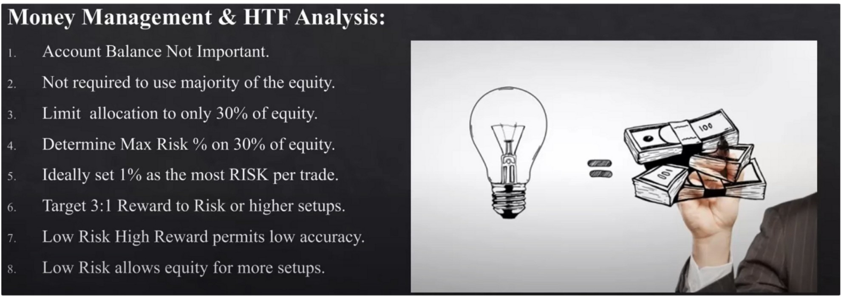

Annual return, 18% to 25% is good and an industry standard for managed funds. If you can do that every single year, ICT promises you youll never have a shortage of investors. He'll let you know how to reach out to investors later in the series.

He talks about managing funds on the **HTF,** so theres not a lot of setups a year

When you use the 30% of your equity for long term trades, that allows you to have margin for short term trades. In the US they cant hedge their trades, but they can trade correlated pairs their in for a long term position. If the long term position has a retracement youre going to experience some drawdown, so the way you can counteract that is to short and hedge the long term position on a short term basis, so long position USDJPY and a retrcament happens long term position then we can hedge trough EURUSD for example on the short term. lntramarket analysis is important for this.

On **HTF** requires patience, resist the urge to move the stop loss too soon

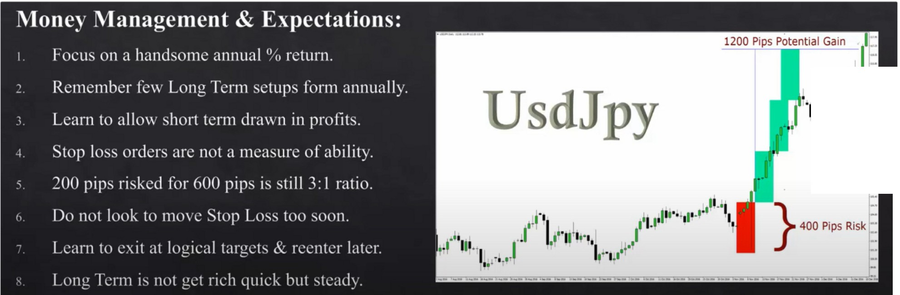

**11,,,-,f'**1:

I •

Everyone should atleast apply the long term trades, its great to learn. Focus on 2 really good setups a year

Thats the reason why large fund managers are always on vacation, they dont trade everyday

Aim for the low hanging fruit, investors will love you and talk about you to their friends. Focus on very little drawdown. Drawdown happens by being in the market a lot.

A lot of people will test you first with smaller amounts of money.

Were not trying to impress anyone once we get more money, keep doing the same thing.

You dont want to be working hard when managing money, you want to be working smart. It takes very little to do very well on the higher timeframes

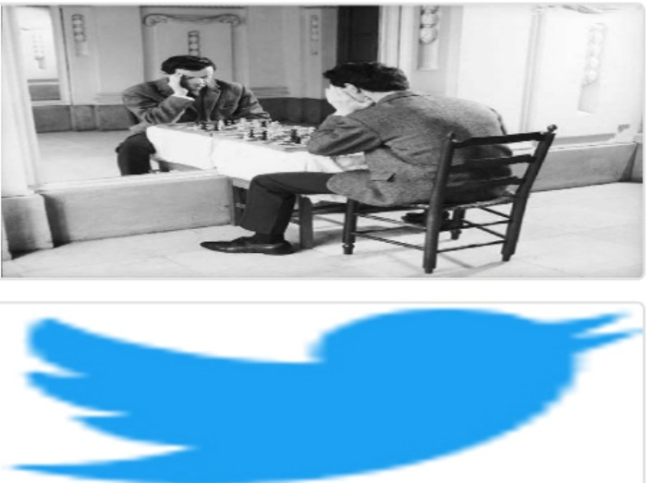Arjo I Twitter, lnstagram I Linktree

Linktree. Make your link do more.

, https://t.co/HhmmTN1fUI

JavaScript is not available.

*"'JI* https://twitter.com/arjoio